GOVERNMENT POLYTECHNIC

KANPUR

Department of Information Technology

LAB MANUAL
FOR

WEB DEVELOPMENT USING PHP

Submitted By:- Submitted To:-
Vivek Patel Vineet Singh sir

DEPARTMENT OF INFORMATION TECHNOLOGY

INDEX

S.No | List of Practicals | Page No | Date | Signature
1 | Design the following static web pages required for an online book store web site.  i. Home Page ii. Login Page | 3-4
2 | Design the following static web pages required for an online book store web site.  i. Registration Page ii. Cart Page | 5-6
3 | Design a web page using CSS which includes the following:  i. Use different font and text styles  - Set a background image for both the page and single element on the page. | 7-9
4 | Write a JavaScript to validate the fields of the login page. | 10-11
5 | Write an XML file which will display the Book information which includes the following: Title of the book, Author Name, ISBN number, Publisher name, Edition and  Price. Validate the above document using DTD and XML Schema. | 12-14
6 | Write a PHP program to validate the fields of the login page. | 15-16
7 | Design website using WordPress | 17-19
8 | Design a JSP to insert the details of the users who register through the registration page and store the details in to the database. | 20-22
9 | Write a PHP program to connect to MySQL database which retrieves the data from the tables and display them to the user. | 23-26
10 | Write a PHP program to insert the details entered by the user in the Registration form  into MySQL database. | 26-28

Practical No:- 1
AIM: Design the following static web pages required for an online book store web site.
i. Home Page ii. Login Page iii. Catalogue Page

HOME PAGE:
The static home page must contain three frames.

Top frame : Logo and the college name and links to Home page, Login page, Registration page, Catalogue page and Cart page (the description of these pages will be given below).
Left frame : At least four links for navigation, which will display the catalogue of respective links. For e.g.: When you click the link “CSE” the catalogue for CSE Books should be displayed in the Right frame.
Right frame: The pages to the links in the left frame must be loaded here. Initially this page contains description of the web site.

Source Code

home.html
<html>
<head>
<frameset rows="20%,80%">
<frame name="title" src="titlepage.html">
<frameset cols="25%,75%">
<frame name="list" src="list.html">
<frame name="display" src="display.html">
</frameset>
</frameset>
</head>
</html>

titlepage.html
<html>
<head>
<title>title page</title>
</head>
<body bgcolor="yellow" text="red">
<h1 align="center"> ONLINE BOOK STORE </h1>
</body>
</html>

list.html
<html>
<head>
<title> List</title>
</head>
<body bgcolor="pink">
<center>
<a href="login.html" target="display">
<b> LOGIN </b></a><br>
<a href="catalogue.html" target="display"><b> CATALOGUE </b></a>
</center>
</body>
</html> Left.html
<html>
<head>
<title>Top Page</title>
</head>
<body><a href="cse.html" target="body">CSE</a>

<br /><a href="ece.html" target="body">ECE</a><br />
<a href="eee.html" target="body">EEE</a><br />
<a href="civil.html" target="body">CIVIL</a><br /></body>
</html>

OUTPUT



Login.html
<html>
<body bgcolor="cyan">
<h2 align="center">LOGIN PAGE</h2>
<center>
<form>
<table border="1">
<tr>
<td><label>USER NAME</label></td>
<td><input type="text" name="uname"></td>
</tr>
<tr>
<td><label>PASSWORD</label></td>
<td><input type="password" name="pwd"></td>
</tr>
<tr>
<td><input type="submit" value="LOGIN"></td>
</tr>
</table>
</form>
</center>
</body>
</html>


OUTPUT

Practical NO:- 2

Aim: Design the following static web pages required for an online book store web site.
i. Registration Page ii. Cart Page

CART PAGE:
The cart page contains the details about the books which are added to the cart. The cart page should look like this:



Description
Through table and form tag we can design pages.
The form tag you can add to your web pages a guestbook, order forms, surveys, get feedback or whatever. The basic construction of a html form is this...
<FORM> begin a form
<INPUT> ask for information in one of several different ways...
<INPUT> ...there can be as many input areas as you wish
</FORM> end a form

<TABLE>
The main tag. Used to tell the browser "this is a table", along with some attributes like size, border width and a few other thing<TR>

<TD>

Table Row defines a horizontal row of <TD> (Table Data) cells. Specifies an individual block or cell in a table row

Source Code

Cart.html
<html>
<body bgcolor="orange" >
<h1 align="center">CATALOGUE PAGE</h1>
<center>
<table border="1">
<tr>
<th> COVER IMAGE</th>
<th> AUTHOR NAME</th>
<th> TEXT BOOK-NAME</th>
<th> PRICE</th>
<th> ADD TO CART</th>
</tr>
<tr>
<td><imgsrc="c#.jpg" height="105" width="150"></td>
<td>Harsh Bhasin</td>
<td> Programming in C#</td>
<td>200/</td>
<td><input type="button" value="ADD TO CART"</td>
<tr>
<td><imgsrc="cn.jpg" height="105" width="150"></td>
<td>Andrew S Tanenbaum</td>
<td>Computer Networks</td>

<td>400/</td>
<td><input type="button" value="ADD TO CART"</td>
<tr>
<td><imgsrc="wt.jpg" height="105" width="150"></td>
<td>Chris Bates</td>
<td>Web Programming, Building Internet Applications</td>
<td>599/</td>
<td><input type="button" value="ADD TO CART"</td>
<tr>
<td><imgsrc="wt1.jpg" height="105" width="150"></td>
<td>Kogent</td>
<td>Web Technologies, Black book</td>
<td>499/</td>
<td><input type="button" value="ADD TO CART"</td>
</table>
</center>
</bdoy>
</html>

Execution Procedure
Step1: type all html programs in notepad or any text editor and save .html format. Step2: open web browser and open index.html, i.e previous week.
Step3: traverse all pages from index.html.

Practical NO:- 3

Design a web page using CSS which includes the following:
- Use different font and text styles
- Set a background image for both the page and single element on the page.

- Use different font, styles:
In the style definition you define how each selector should work (font, color etc.). Then, in the body of your pages, you refer to these selectors to activate the styles.

For example:
<HTML>
<HEAD>
<style type="text/css">
B.headline {color:red, font-size:22px, font-family:arial, text-decoration:underline}
</style>

</HEAD>

<BODY>
<b>This is normal bold</b><br> Selector {cursor:value}

For example:

<html>
<head>
<style type="text/css">
.xlink {cursor:crosshair}
.hlink{cursor:help}
</style>
</head>

<body>
<b>
<a href="mypage.htm" class="xlink">CROSS LINK</a>
<br>
<a href="mypage.htm" class="hlink">HELP LINK</a>
</b>
</body>
</html>

<b class="headline">This is headline style bold</b>
</BODY>

</HTML>

- Set a background image for both the page and single elements on the page. You can define the background image for the page like this:
BODY {background-image:url(myimage.gif),}

Description

- CSS stands for Cascading Style Sheets
- Styles define how to display HTML elements
- Styles are normally stored in Style Sheets
- Styles were added to HTML 4.0 to solve a problem
- External Style Sheets can save you a lot of work
- External Style Sheets are stored in CSS files
- Multiple style definitions will cascade into one

HTML tags were originally designed to define the content of a document.

As the two major browsers - Netscape and Internet Explorer - continued to add new HTML tags and attributes (like the <font> tag and the color attribute) to the original HTML specification, it became more and more difficult to create Web sites where the content of HTML documents was clearly separated from the document's presentation layout.

To solve this problem, the World Wide Web Consortium (W3C) - the non profit, standard setting consortium, responsible for standardizing HTML - created STYLES in addition to HTML 4.0.

Source Code

- Use different font, styles: Fontstyle.html
<html>
<head>
<link rel="stylesheet" href="font.css">
</head>
<body>
<p class="center">My text with font-arial</p>
<p class="right">My text with font-calibre</p>
<p class="left">My text with font-cooper</p>
</body>
</html>

font.css
p.center
{
color:pink;
text-align:center; letter-spacing:3; font-family:arial; font-variant:small; font-weight:bold;

}
p.right
{
color:orange; text-align:right; letter-spacing:10;
font-family:calibre; font-variant:uppercase; font-weight:bold;
}
p.left
{
color:green; text-align:left;
letter-spacing:15; font-family:cooper;
font-variant:uppercase; font-weight:bold;
}

- Set a background image background.html
<html>
<head>
<style type="text/css"> body
{
background-image:url(wt.jpg);

background-repeat:repeat;
}
</style>
</head>
<body>
<h1 align="center">WebTechnology</h1>
</body>

</html>

Execution procedure
Step1: type all html programs in notepad or
any text editor and save .html format.
Step2: open web browser and open .html
files.

Output
- Use diff
- erent font, styles:Set a background image

Practical NO:- 4

AIM:
Write a JavaScript to validate the fields of the login page.

Description
JavaScript is a lightweight interpreted programming language with rudimentary object-oriented capabilities. Syntactically, the core JavaScript language resembles C, C++ and Java, with programming constructs such as the if statement, the while loop, and the && operator. The similarity ends with this syntactic resemblance, however. JavaScript is an untyped language, which means that variables do not have to have a type specified.

The <SCRIPT> and </SCRIPT> tags are used to embed JavaScript code within an HTML file.

Source Code

login.html
<html>
<head>
<title> LOGIN FORM VALIDATION</title>
<script>
function validate()
{
var username=document.getElementById("username").value; var password=document.getElementById("password").value; if(username==null||username==""){
alert("Please enter the username"); return false;
}
if(password==null||password==""){ alert("Please enter the Password"); return false;
}
alert("Login Successful");
}
</script>
</head>
<bodybgcolor="pink">
<font color="red"><h1 align="center">LOGIN FORM VALIDATION</h1></font>
<form name="f1" method="post">
<label>User Name</label>
<input type="text" name="username" id="username"><br>
<label>Password</label>
<input type="password" name="password" id="password"><br>
<input type="button" value="Login" onclick="validate()">&nbsp&nbsp
<input type="reset" name="r1" value="RESET">
</form>
</body>
</html>

Execution Procedure
Step1: type the html program in notepad or any text editor and save .html format. Step2: open web browser and open .html.

Output

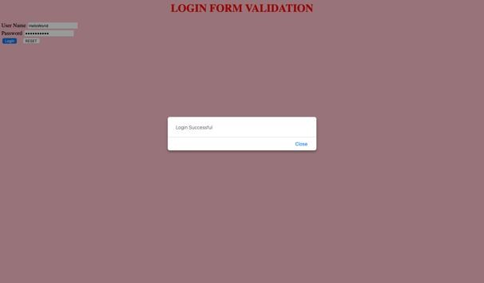
Login Page

Practical NO:- 5

AIM:Write an XML file which will display the Book information which includes the following: Title of the book, Author Name, ISBN number, Publisher name, Edition and Price. Validate the above document using DTD and XML Schema.

Description
Extensible Markup Language (XML) is a meta-markup language that provides a format for describing structured data. This facilitates more precise declarations of content and more meaningful search results across multiple platforms. In addition, XML is enabling a new generation of Web-based data viewing and manipulation applications.
In the HTML you use tags to tell the browser to display data as bold or italic; in XML you use tags only to describe data, such as city name, temperature, and barometric pressure. In XML, you use style sheets such as Extensible Stylesheet Language (XSL) and Cascading Style Sheets (CSS) to present the data in a browser. XML separates the data from the presentation and the process, enabling you to display and process the data as you wish by applying different style sheets and applications.

Source Code
- Demonstrating DTD file

bookstore.dtd
<!ELEMENT bookstore (book+)>
<!ELEMENT book (title,author+,ISBN,publisher,edition,prices)>
<!ELEMENT title (#PCDATA)>
<!ELEMENT author (#PCDATA)>
<!ELEMENT ISBN (#PCDATA)>
<!ELEMENT publisher (#PCDATA)>
<!ELEMENT edition (#PCDATA)>
<!ELEMENT prices (#PCDATA)>

books.xml
<?xml version="1.0"?>
<!DOCTYPE bookstore SYSTEM "bookstore.dtd">
<bookstore>

<book>
<title>Web Programming, Building Internet Applications</title>
<author>Chris Bates </author>
<ISBN>123-456-789</ISBN>
<publisher>Wiley</publisher>
<edition>2nd</edition>
<prices>329</prices>
</book>

<book>
<title>Web Technologies, Black book</title>
<author>Kogent</author>

<ISBN>123-456-789</ISBN>
<publisher>Dreamtech</publisher>
<edition>2nd</edition>
<prices>229</prices>
</book>

<book>
<title>WEB TECHNOLOGIES</title>
<author>Uttam.K.Roy</author>
<ISBN>123-456-789</ISBN>
<publisher>Oxford</publisher>
<edition>2nd</edition>
<prices>429</prices>
</book>

</bookstore>

- Demonstrating XSD book-schema.xsd

<?xml version="1.0" ?>
<xs:schemaxmlns:xs="http://www.w3.org/2001/XMLSchema">
<xs:element name="bookstore">
<xs:complexType>
<xs:sequence>
<xs:element name="book">
<xs:complexType>
<xs:sequence>
<xs:element name="title" type="xs:string"/>
<xs:element name="author" type="xs:string"/>
<xs:element name="ISBN" type="xs:int"/>
<xs:element name="publisher" type="xs:string"/>
<xs:element name="edition" type="xs:int"/>
<xs:element name="prices" type="xs:int"/>
</xs:sequence>
</xs:complexType>
</xs:element>
</xs:sequence>
</xs:complexType>
</xs:element>
</xs:schema>

Book-schema.xsl
<?xml version="1.0"?>
<bookstore xmlns:xsi="http://www.w3.org/2001/XMLSchema-instance" xsi:noNamespaceSchemaLocation="book-schema.xsd">

<book>
<title>Web Programming, Building Internet Applications</title>
<author>Chris Bates </author>
<ISBN>123456789</ISBN>
<publisher>Wiley</publisher>
<edition>2</edition>
<prices>329</prices>
</book>

<book>
<title>Web Technologies, Black book</title>
<author>Kogent</author>
<ISBN>123-456-789</ISBN>
<publisher>Dreamtech</publisher>
<edition>2nd</edition>
<prices>229</prices>
</book>

<book>
<title>WEB TECHNOLOGIES</title>
<author>Uttam.K.Roy</author>
<ISBN>123-456-789</ISBN>
<publisher>Oxford</publisher>
<edition>2nd</edition>
<prices>429</prices>
</book>
</bookstore>

Execution Procedure
Step1: Type all html programs in notepad or any text editor and save the files. Step2: open appropriate xml files in web browser for getting output.

Output
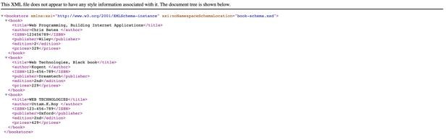

Demonstrating XSD

Practical NO:- 6

AIM:

Write a PHP program to validate the fields of the login page.

DESCRIPTION:
This PHP login application uses MySQL database to store user information and all the input parameters are validated with javascript.This PHP login page using MySQL database connections contains PHP 7.0 methods only. Many methods like mysql_real_escape_string(), mysql_query(), mysql_num_rows(), mysql_connect(), mysql_select_db(), mysql_close() were depricated in PHP 5 and removed from the latest version of PHP i.e. PHP 7.0.

ALGORITHM:
LoginForm.php
Step 1:-Open the html tag and the title as LoginForm.php. Step 2:-Declare the validate() function.
Step 3:-Design login form with username, password, submit and reset values. Step 4:-if anyone not enter user name or password it shows alert message.
Step 5:-close the html tag.

Login.php
Step 1:-Open the html and body tag.
Step 2:-Open the MYSQL database connection.
Step 3:-if the $_SERVER['REQUEST_METHOD'] == 'POST' then Step 4:-enter user name and password
Step 5:-check the user name and password is valid or not Step 6:-if valid then display the login page
Step 7:-otherwise it shows incorrect username and password. Step 8:-close body and html tags.

PROGRAM:
login.html
<html>

<body bgcolor=azure>
<form name="LoginForm" action="http://localhost:2424/19batch/login- validate.php" method="post">
<fieldset>
<legend align=center><h2>Login Here</h2></legend>
<table cellpadding=5 align=center>
<tr>
<td>User Name</td>
<td> : </td>
<td><input type="text" name="t1" class="textbox" placeholder="Only Characters" /></td>
</tr>
<tr>
<td> Password </td>
<td> : </td>

<td><input type="Password" name="t2" class="textbox" placeholder="Max 15 characters"/></td>
</tr>
<tr>

value="LOGIN" /></td>

value="RESET" /></td>
</tr><td ><input type="submit" class="button button1"

<td></td>
<td ><input type="reset" class="button button1"
</table>
</form>
</body>
</html>

Login-validation.php
<?php
$user=$_POST['t1'];
$pwd=$_POST['t2'];
$uname_pat='/^[a-zA-Z0-9]{5,13}$/';
$pwd_pat='/^[a-zA-Z0-9@$& ]{5,13}$/';
$flag=true; if($user=="") {
$flag=false;
echo "PLEASE Enter the user name ";

}
else if($pwd=="") {
$flag=false;
echo "PLEASE Enter the password ";
}
else if(preg_match($uname_pat,$user)==false) {
$flag=false;
echo "Please Enter UserName Format"; Output:

}
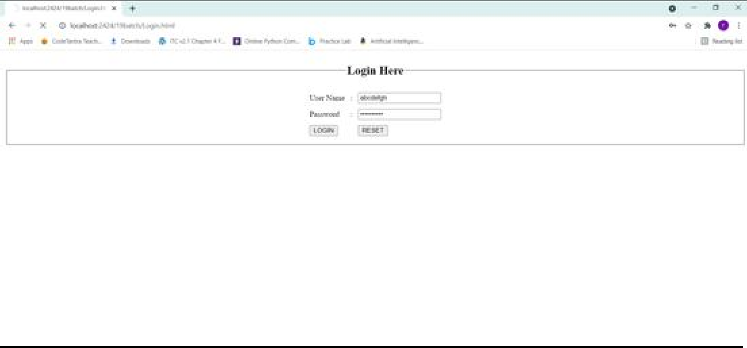
else if(preg_match($pwd_pat,$pwd)==false) {
$flag=false;
echo "Please Enter Password Format";
}
else if($flag==true) {
echo "All Details are valid";
}

?>
}

?>

Practical NO:- 7

AIM:Write a JSP to connect to the database and extract data from the tables and display them to the user.

DESCRIPTION

Source Code:

How to Create a Website on WordPress
Knowing the components of WordPress gives a good understanding of how to build a website. The following are some of the core components of WordPress that help in better understanding:
- WordPress Core – runs all the basic functionality, manages the content, and interaction between the databases, authentication system, etc.
- Extra Files – files added with ease in addition to the core files using WordPress’s Dashboard option.
- Database – uses MYSQL as its database to store the files.
- Admin screen – manages the site and configures all the tasks of WordPress.
Using WordPress.com to create a website as it is more beginner-friendly compared to using WordPress.org:

Step 1: Hosting Platform
Numerous hosting platforms on the Internet are specifically designed to host websites. For example, there are platforms like Bluehost, GoDaddy, HostGator, DreamHost, Kinsta, A2 Hosting, that provide various plans to choose the best one’s for a website. If the domain is hosted externally, WordPress suggests having the hosting platforms as Bluehost or DreamHost. In this article, the article is hosted on Bluehost platform.
WordPress also allows launching the websites for free but a paid plan is required to access its advanced features, plugins and themes.

Step 2: Domain Selection
Domain name is the name of your site. Domain names should be accurate and easy to remember. It should be relevant to the content of the website as it can bring good recognition on the Internet. And using TLDs (Top Level Domain) to generate domain extensions can be helpful.
Example: www.geeksforgeeks.org
Here, geeksforgeeks is the domain name and .org is the TLD. Similarly there are lots of TLD’s available – .com, .co, .in etc.
Creating Domain: The domain can be created in the Purchase Domain section under the Domains section on Bluehost.

Step 3: Installing WordPress on Bluehost
Now the next step is to create the website.
To create a new site, find My Sites section in the left panel of main screen and click on the area inscribed in a rectangular plot. Now, go to create new site or click on Migrate Existing Site if you already have an existing site.
My sites >> Add Site >> Create new site or Migrate Existing site
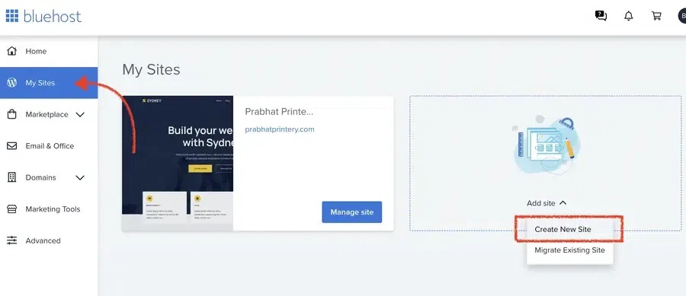
After the installation, use the authenticated credentials to log into the WordPress Dashboard to access the website.
Note that WordPress allows creating of multiple websites within the same installation
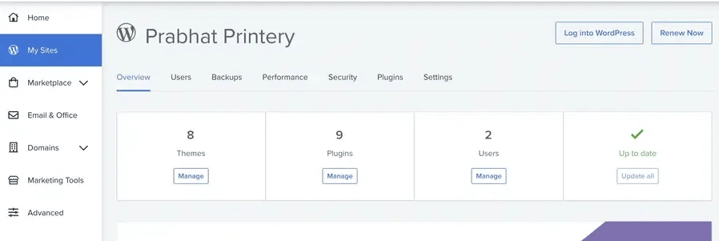

Step-4: Themes in WordPress
WordPress has various themes that are designed by professionals and can be installed on the website to alter the visuals. WordPress has both paid and free themes. The theme of the website can be changed anytime from the admin dashboard.
- Installing a New Theme on WordPress: To install a new theme, click on Appearance section and move to Themes. Now, click on the Add New Theme option at the end.
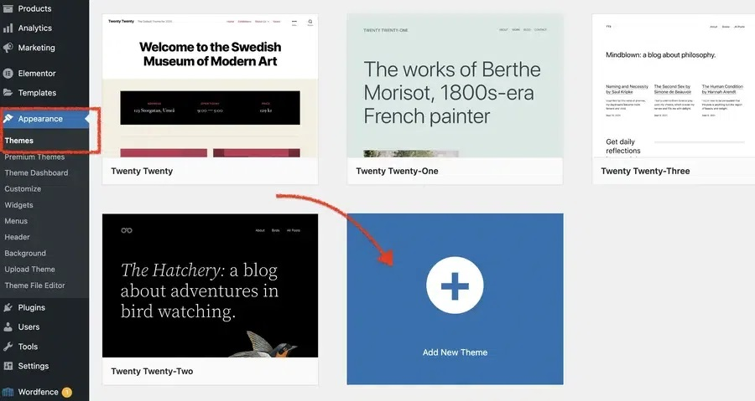

Now, look for your favourite theme and click on install option. You can also preview before installing the theme.
After installing the theme, it can be customized using the customize option in the Appearance section where the settings can be adjusted.
You can also use the Editor option from the Appearance section to edit the website visuals.
- Changing Current Theme on WordPress: To change the current theme, go to the Appearance section on the left pane of the screen, a drop-down will pop up choose the Themes option. Now, available themes would be displayed. Activate the theme you want.
Appearance >> Themes >> Activate
- Customising the Themes: After selecting the themes, you can edit or customise different sections of your website. To customise your site, go to the Appearance section and click on Customize to edit different sections.
Now, you can customise each section of the website separately.
- Save and Publish: Now to save your work on WordPress and publish your site. Just click on save and make your site public by publishing it.
Click Save >> Publish
By clicking on publish, our website would be made public and live to view. The website created with these steps would be a basic one.

Practical NO:- 8
AIM:Design a JSP to insert the details of the users who register through the registration page and store the details in to the database.

PROGRAM:

Registration.html
<html>
<head><title>register</title></head>
<body>
<center><br><br><br><h1><font size="22" color="pink"><i>Registration</font></h1></i>
<form action="registration.jsp" method="post" name="reg" id="rn" onSubmit="return validate( )">
<table><tr><td>Name:<td><input type="text" name="na" size="10"></td></tr>
<tr><td>Gender:</td><td><input type="Radio" name="gender" >Male<input type="Radio" name="gender" >Female</td></tr>
<tr><td>Date of birth:</td><td><input type="date" name="dob" size="10"></td></tr>
<tr><td>Rollno:</td><td><input type="text" name="roll" size="10"></td></tr>
<tr><td>Phone no:</td><td><input type="text" name="pno" size="10"></td></tr>
<tr><td>Email id:</td><td><input type="text" name="mail" size="30"></td></tr>
<tr><td>Password:</td><td><input type="password" name="pwd" size="10"></td></tr>
<tr><td>Re-enter Password:</td><td><input type="password" name="rpwd" size="10"></td></tr>
<tr><td>Branch:</td><td><select name="br"><option value="default">Select branch</option><option value="IT">Information Technology</option><option value="CSE">Computer Science Engineering</option><option value="ECE">Electronics and Communication Engineering</option><option value="EEE">Electrical and Electronics Engineering</option><option value="CIVIL">Civil Engineering</option><option value="MECH">Mechanical Engineering</option></td></tr>
<tr><td>College:</td><td><input type="text" name="col" size="10"></td></tr>
<tr><td>Address:</td><td><textarea name="add" rows="4" cols="30"></textarea></td></tr>
<tr><td><input type="submit" value="Register"></td><td><input type="reset" value="reset"></td></tr></table>
</form>
</body>
</html>

registration.jsp
<%@page import="java.sql.*"%>
<html>
<body>
<%
String Name=request.getParameter("na"); String Gender=request.getParameter("gender"); String Dob=request.getParameter("dob"); String Rollno=request.getParameter("roll"); String Phoneno=request.getParameter("pno"); String E_mail=request.getParameter("mail"); String Password=request.getParameter("pwd"); String Branch=request.getParameter("br"); String College=request.getParameter("col");

String Address=request.getParameter("add"); try{ Class.forName("com.mysql.jdbc.Driver");
Connection con=DriverManager.getConnection("jdbc:mysql://localhost:3306/srimanth","root",""); Statement st=con.createStatement();
PreparedStatementps=con.prepareStatement("insert into student(Name,Gender,Dob,Rollno,Phoneno,E_mail,Password,Branch,College,Address)values(?,?,?,
?,?,?,?,?,?,?)");
ps.setString(1,Name); ps.setString(2,Gender); ps.setString(3,Dob); ps.setString(4,Rollno); ps.setString(5,Phoneno); ps.setString(6,E_mail); ps.setString(7,Password); ps.setString(8,Branch); ps.setString(9,College); ps.setString(10,Address); int x=ps.executeUpdate();
%><a href="welcome.jsp">Register</a><%
}
catch(Exception e) { out.print(e.getMessage());
}
%>
</body>
</html>

welcome.jsp
<html>
<body bgcolor="green"><center>
<font size="22" color="red">
<%
out.print("1 record added");
out.print("<br> You want to register another user");

%>
Click <a href=”Registration.html”>here</a>
</font>
</center>
</body>
</html>

OUTPUT:

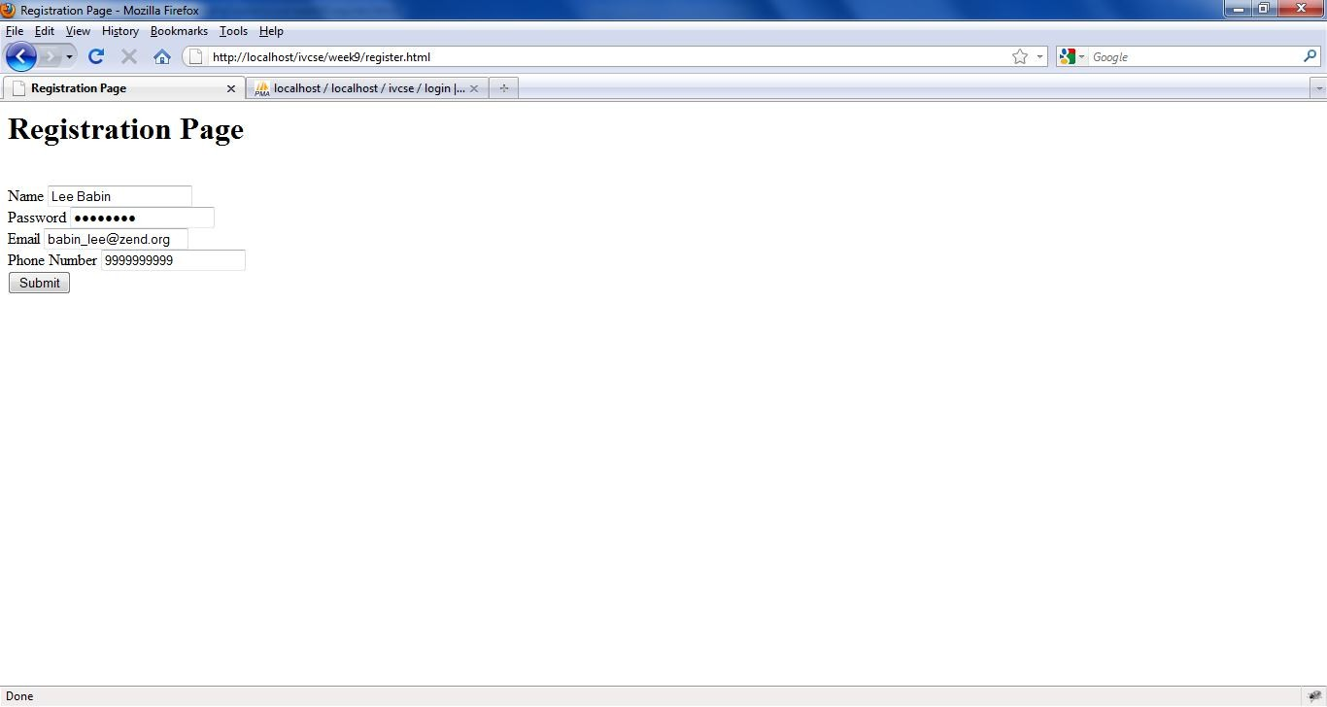
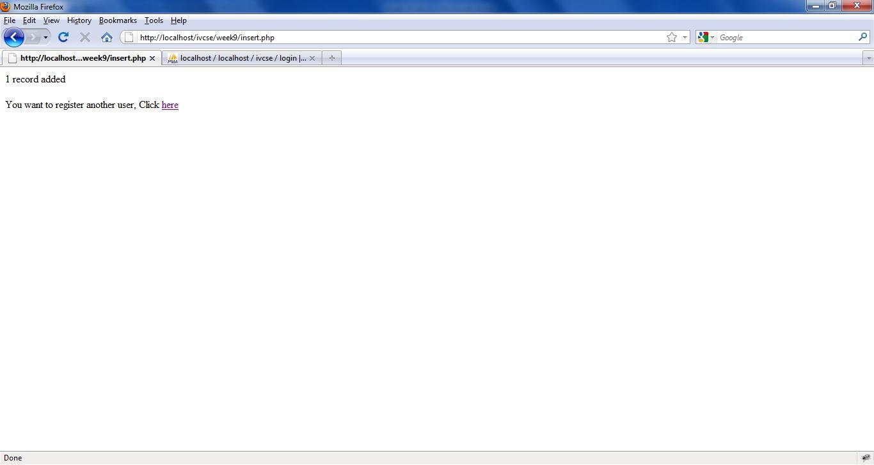

Practical NO:- 9

AIM:
Write a PHP program to connect to MySQL database which retrieves the data from the tables and display them to the user.

Description
Create a Connection to a MySQL Database
Before you can access data in a database, you must create a connection to the database. In PHP, this is done with the mysqli_connect() function.
Syntax mysql_connect(servername,username,password,dbname);

Parameter | Description
Servername | Optional. Specifies the server to connect to. Default value is "localhost:3306"
Username | Optional. Specifies the username to log in with. Default value is the name of the user that owns the server process
Password | Optional. Specifies the password to log in with. Default is ""
Dbname | Database Name

Example
In the following example we store the connection in a variable ($con) for later use in the script. The "die" part will be executed if the connection fails:
<?php
$con = mysqli_connect(“localhost”,”root”,””,’srikanth’); if (!$con)
{
die('Could not connect: ' . mysql_error());
}

// some code
?>

Closing a Connection
The connection will be closed automatically when the script ends. To close the connection before, use the mysql_close() function:
<?php
$con = mysqli_connect("localhost","root","",”srikanth”); if (!$con)
{
die('Could not connect: ' . mysql_error());
}
// some code mysql_close($con);
?>

Source code

Step by step procedure for creating table in php my admin

MySQL is automatically installed along with WAMP server installation. User environment for MySQL in WAMP is “phpMyAdmin”.

Step1: Start WAMP server

Step2: Click WAMP server icon on taskbar and select “phpMyAdmin” option.

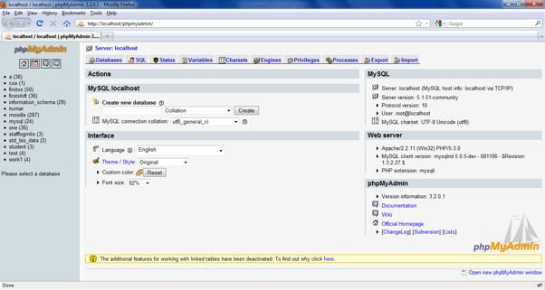

It automatically opens “phpMyAdmin” screen.

Step3: create New Database.
Provide database name on “create new database” field and click “create” button. The following screen displays in your computer

Step 4: Click database “ivcse” i.e appeared left panel of phpMyAdmin Screen. It displays following screen

Step5: Creating a table.
The Aim indicates that you can create which should contain at least the following fields: name, password, email-id, phone number. So here 4 fields are there.
Provide table name “login” and “number of fields:” 4 Click “Go” button. It displays following screen

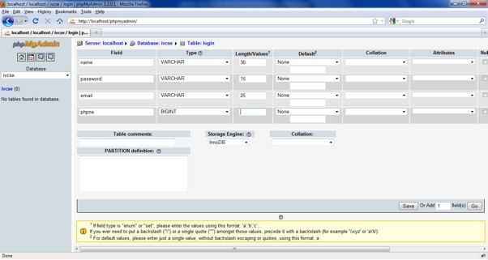
Step 6: Provide fields name and its datatype, size like the following screen

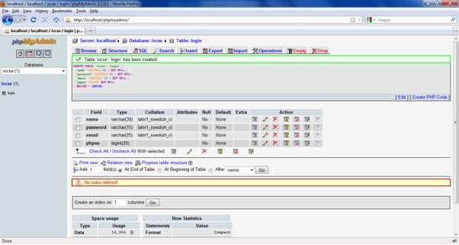
Step 7: click “Save”. It create login table and displays “Table ‘ivcse’,’login’ has been created.”
Step 8: click on table name on left panel of phpMyAdmin, you can see structure of table i.e field name datatype and other parameters.
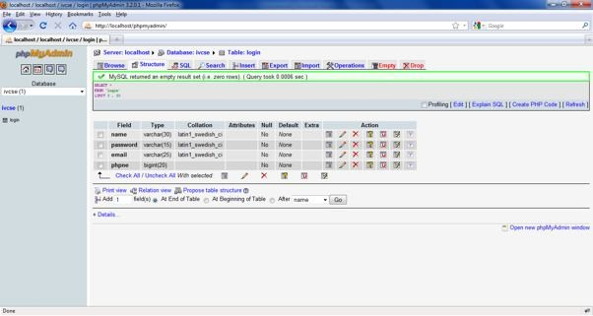

Display.php
<?php
$con = mysqli_connect("localhost","root","","srikanth"); if (!$con)
{
die('Could not connect: ' . mysqli_error());
}

mysql_select_db("ivcse", $con);
$result = mysqli_query($con, "SELECT * FROM login"); echo "<table border='1'>
<tr>
<th>Name</th>
<th>Password</th>
<th>Email</th>
<th>Phone Number</th>
</tr>";

while($row = mysql_fetch_array($result))
{
echo "<tr>";
echo "<td>" . $row['name'] . "</td>"; echo "<td> Not shown</td>";
echo "<td>" . $row['email'] . "</td>";
echo "<td>" . $row['phno'] . "</td>"; echo "</tr>";
}
echo "</table>";

mysqli_close($con);
?>

Execution procedure
Step1: Type all programs and save with .php extension in c:\WAMP\WWW directory. Step2: Run WAMP Server.
Step3: Through localhost execute your programs.
url’s are: http://localhost/display.php&&http://localhost/insert.php

Output
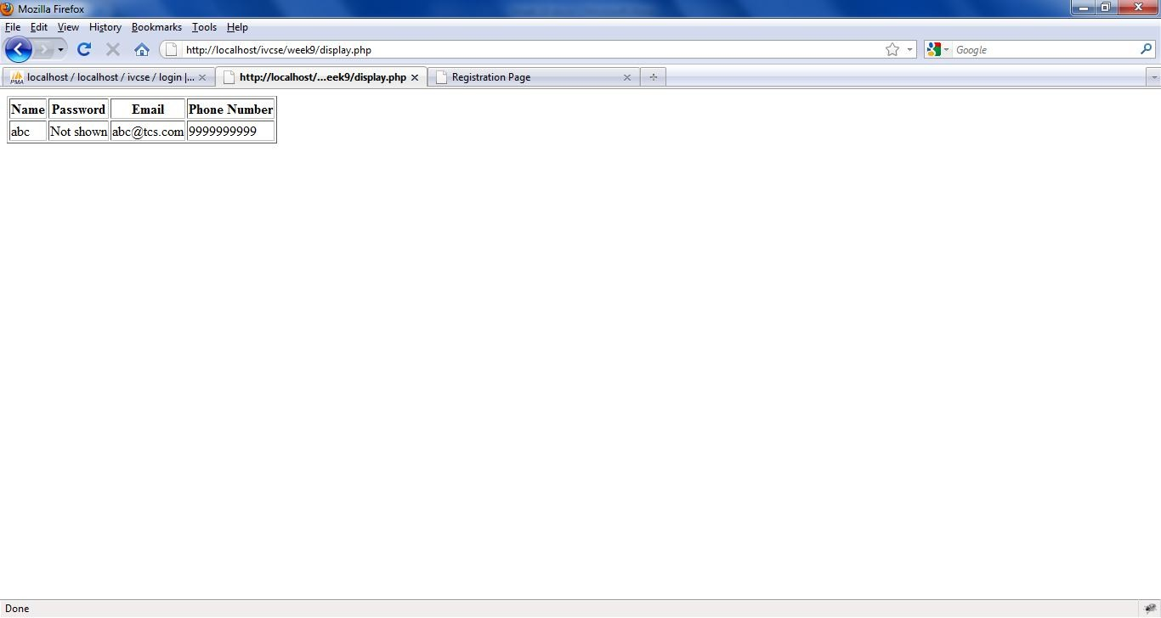
Displaying data from Database

Registering New User

After providing all fields of data and Click on Submit button

After successfully added 1 user

Practical NO:- 10

AIM:
Write a PHP program to insert the details entered by the user in the Registration form into MySQL database.

DESCRIPTION:

PROGRAM-1:
Register.php
<html>
<title>Registration Page</title>
</head>
<body>
<h1> Registration Page</h1>
<br />
<form action="insert.php" method="post">
Name <input type="text" name="fname" id="fname" value="name" /><br /> Password <input type="password" name="pwd" id="pwd" value="password" /><br />
Email <input type="text" name="email" id="email" value="email@example.com"/><br />
Phone Number <input type="text" name="ph" id="ph" value="9999999999" maxlength="10"/><br
/>
<input type="submit" value="Submit" />
</form>
</body>
</html> Insert .php

<?php
$con = mysqli_connect("localhost","root","root","srikanth"); if (!$con)
{
die('Could not connect: ' . mysql_error());
}

mysql_select_db("ivcse", $con);

$sql="INSERT INTO login (name, password, email, phno) VALUES
('$_POST[fname]','$_POST[pwd]','$_POST[email]','$_POST[ph]')";

if (!mysqli_query($con,$sql))
{
die('Error: ' . mysqli_error());
}
echo "1 record added"; echo "<br><br>";
echo "You want to register another user, Click <a href='register.html'>here</a>";

mysqli_close($con);
?>

Output:

